
"AI-Based Driver Drowsiness Detection and Automatic Speed Control System with Alcohol Monitoring"
A PROJECT REPORT
submitted by
B. SANDHIYA
(Register No: 922524105046)
in partial fulfilment for the award of the degree of
BACHELOR OF ENGINEERING
in
ELECTRICAL AND ELECTRONICS ENGINEERING
V.S.B. ENGINEERING COLLEGE, KARUR
(AUTONOMOUS)
AFFILIATED TO ANNA UNIVERSITY, CHENNAI 600 025
JULY 2026

BONAFIDE CERTIFICATE
This is to certify that the project report titled "AI-Based Driver Drowsiness Detection and Automatic Speed Control System with Alcohol Monitoring" is the bonafide work of B. SANDHIYA (Register No: 922524105046), who carried out the project work under my supervision during the academic year 2025-2026, in partial fulfilment for the award of the degree of Bachelor of Engineering in Electrical and Electronics Engineering.
SIGNATURE
Dr. R. Arun Kumar
PROJECT GUIDE
Department of Electrical and Electronics Engineering
SIGNATURE
Dr. Umamaheswari
HEAD OF THE DEPARTMENT
Department of Electrical and Electronics Engineering
Submitted for the project viva-voce examination held on ______________.
Internal Examiner External Examiner

ACKNOWLEDGEMENT
I express my sincere gratitude to the management of V.S.B. Engineering College, Karudayampalayam, Karur, for providing the necessary infrastructure and laboratory facilities to carry out this project successfully.
I am deeply thankful to my project guide, Dr. R. Arun Kumar, Department of Electrical and Electronics Engineering, for the valuable guidance, constant encouragement, and constructive suggestions extended throughout the course of this project titled "AI-Based Driver Drowsiness Detection and Automatic Speed Control System with Alcohol Monitoring".
I extend my heartfelt thanks to the Head of the Department, Dr. Umamaheswari, and all the faculty members of the Department of Electrical and Electronics Engineering for their continuous support, technical guidance, and encouragement at various stages of this project.
Finally, I thank my parents, friends, and classmates for their continuous encouragement, cooperation, and moral support, without which this project would not have been completed successfully.
B. SANDHIYA

ABSTRACT
AI-Based Driver Drowsiness Detection and Automatic Speed Control System with Alcohol Monitoring is an intelligent embedded safety system designed to prevent road accidents caused by driver fatigue, unsafe following distance, and alcohol consumption. The system continuously monitors the driver's eye state, the vehicle's cabin alcohol level, and the surrounding obstacle distance, and takes corrective action automatically whenever an unsafe condition is detected.
A NodeMCU ESP8266 module forms the core of the system. An IR eye blink sensor, mounted on a pair of safety goggles, continuously monitors the driver's eye state to detect prolonged eye closure associated with drowsiness. An MQ-3 gas sensor screens the cabin air for the presence of alcohol, while an HC-SR04 ultrasonic sensor measures the distance to obstacles ahead of the vehicle.
When drowsiness, alcohol, or a nearby obstacle is detected, the NodeMCU ESP8266 automatically reduces the speed of a DC geared motor through an L298N motor driver, bringing the vehicle to a safe, controlled stop when the condition is severe. A 16×2 LCD display provides the driver with a continuous, real-time readout of the alcohol level, obstacle distance, and motor speed/system status, while the NodeMCU's built-in Wi-Fi hosts a web dashboard for live remote monitoring and manual RUN/STOP control. This project demonstrates a low-cost, scalable, and reliable multi-sensor safety solution that can be integrated into two-wheelers, four-wheelers, and public transport vehicles to significantly reduce fatigue- and alcohol-related road accidents.

TABLE OF CONTENTS
Section | Contents | Page No.
 | Bonafide Certificate | 2
 | Acknowledgement | 3
 | Abstract | 4
 | Table of Contents | 5
Chapter 1 | Introduction | 6
1.1 | Background | 6
1.2 | Objectives | 7
1.3 | Scope of the Project | 8
Chapter 2 | Literature Survey | 9
Chapter 3 | System Design / Methodology | 10
3.1 | System Architecture | 10
3.2 | Block Diagram | 11
3.3 | Flowchart | 12
3.4 | Hardware Requirements | 13
3.5 | Software Requirements | 15
3.6 | AI-Based Safety Features | 16
3.7 | Development Process | 17
Chapter 4 | Implementation | 18
4.1 | Project Development | 18
4.2 | Circuit Diagram | 19
4.3 | NodeMCU ESP8266 Program (Source Code) | 20
4.4 | Working Principle | 22
4.5 | Implementation Steps | 23
4.6 | Hardware Prototype | 23
Chapter 5 | Results and Discussion | 24
5.1 | Output | 24
5.2 | Testing | 25
5.3 | Observations | 25
5.4 | Advantages | 26
Chapter 6 | Conclusion and Future Scope | 27
6.1 | Conclusion | 27
6.2 | Future Scope | 27
6.3 | References | 28

Chapter 1 - Introduction

1.1 Background
Road traffic accidents caused by driver fatigue, unsafe following distance, and drink-driving remain among the leading causes of fatal collisions worldwide. Studies by transport safety authorities consistently identify drowsy driving and alcohol consumption as major contributors to single-vehicle crashes, particularly on highways and during long-distance or night-time travel. Conventional vehicles offer little to no real-time monitoring of the driver's physical condition or the surrounding traffic environment, relying almost entirely on the driver's own self-awareness, which becomes unreliable precisely when fatigue or intoxication sets in.
With the advancement of low-cost embedded sensors and Internet-of-Things (IoT) connectivity, it has become feasible to build an intelligent in-vehicle safety system that continuously observes the driver and the surrounding environment, and intervenes automatically before an accident occurs. The AI-Based Driver Drowsiness Detection and Automatic Speed Control System with Alcohol Monitoring is designed to address this need by combining an IR eye blink sensor with an MQ-3 alcohol sensor and an HC-SR04 ultrasonic sensor around a NodeMCU ESP8266 controller to create a self-monitoring, self-acting driver-safety solution.
The system uses an IR eye blink sensor, mounted on a pair of safety goggles worn by the driver, to continuously monitor eye closure and detect prolonged closure associated with drowsiness. Simultaneously, the MQ-3 sensor checks for the presence of alcohol in the cabin air, while the HC-SR04 ultrasonic sensor measures the distance to obstacles ahead of the vehicle. Based on the combined sensor data, the NodeMCU ESP8266 controller decides the appropriate motor speed and progressively reduces it through the L298N motor driver stage, updates the 16×2 LCD display, and publishes live status to a Wi-Fi web dashboard, all without requiring any manual intervention.

1.2 Objectives
- To design and develop an embedded driver-safety system using the NodeMCU ESP8266 microcontroller with built-in Wi-Fi connectivity.
- To continuously monitor the driver's eye state, the cabin alcohol level, and the distance to obstacles ahead using an IR eye blink sensor, an MQ-3 sensor, and an HC-SR04 ultrasonic sensor respectively.
- To detect drowsiness indicators such as prolonged eye closure in real time using the IR eye blink sensor mounted on safety goggles.
- To automatically calculate and apply a safe motor speed through an L298N motor driver when drowsiness, alcohol, or a nearby obstacle is detected.
- To update a 16×2 LCD display with the live status of the alcohol level, obstacle distance, and motor speed/system status.
- To host a Wi-Fi-based web dashboard on the NodeMCU ESP8266 for live remote monitoring and manual RUN/STOP control of the vehicle.
- To design a low-cost, compact, and scalable safety module suitable for retrofitting into two-wheelers and four-wheelers.

1.3 Scope of the Project
The AI-Based Driver Drowsiness Detection and Automatic Speed Control System with Alcohol Monitoring aims to provide an affordable, scalable, and intelligent safety solution suitable for private vehicles, two-wheelers, taxis, and public transport. The system uses a NodeMCU ESP8266 microcontroller integrated with an IR eye blink sensor for drowsiness monitoring, an MQ-3 alcohol sensor, and an HC-SR04 ultrasonic sensor for obstacle-distance monitoring.
Based on the collected sensor data, the system automatically drives an L298N motor driver to reduce the speed of a DC geared motor (representing the vehicle drivetrain in the prototype), and updates a 16×2 LCD display and a Wi-Fi web dashboard with live status. The scope of the current implementation focuses on eye-closure-based drowsiness detection, alcohol detection, obstacle-distance monitoring, automatic speed reduction, and remote web-based monitoring/control; the design can be extended in future work to include cloud-based data logging and integration with the vehicle's actual electronic control unit and braking system.

Chapter 2 - Literature Survey
The growing concern over fatigue- and alcohol-related road accidents has driven significant research into driver-monitoring and vehicle-safety systems. Traditional approaches relied on lane-departure sensors and steering-pattern analysis to infer drowsiness indirectly, which often produced delayed or unreliable results, especially in varied driving conditions.
Several studies have demonstrated the use of low-cost infrared (IR) eye-blink and eye-closure sensors to directly detect prolonged eye closure as a strong indicator of drowsiness. Researchers have implemented such sensors on embedded platforms including the ESP8266 and ESP32, enabling low-cost, on-device drowsiness detection without dependence on camera-based image processing or cloud services. Parallel research has explored the use of ultrasonic distance sensors such as the HC-SR04 for real-time obstacle detection, which has been applied in driver-assistance and collision-avoidance systems to enable automatic, distance-graded speed reduction.
In the domain of alcohol detection, MQ-3 semiconductor gas sensors have been widely adopted in low-cost breathalyzer and cabin air-quality monitoring circuits due to their sensitivity to ethanol vapour and ease of interfacing with microcontrollers. A number of prototype systems combine gas sensors with motor-driver-controlled speed-limiting circuits to physically prevent an intoxicated driver from operating the vehicle at normal speed.
More recent research has moved toward multi-sensor fusion architectures, combining eye-closure detection, gas sensing, and distance sensing over Wi-Fi-connected microcontrollers such as the NodeMCU ESP8266, to reduce false alarms and enable remote, web-based monitoring compared to single-sensor, standalone systems. Motor-driver stages such as the L298N are commonly used in prototype and research platforms to emulate automatic speed reduction before such logic is transferred to an actual vehicle's electronic control unit. Building on these findings, the AI-Based Driver Drowsiness Detection and Automatic Speed Control System with Alcohol Monitoring combines IR-based eye-closure detection, alcohol sensing, ultrasonic obstacle sensing, and automatic motor-driver-based speed control with Wi-Fi web monitoring to overcome the limitations of single-sensor, non-connected driver-safety devices, providing a scalable and reliable solution suitable for modern smart vehicles.

Chapter 3 - System Design / Methodology

3.1 System Architecture
The AI-Based Driver Drowsiness Detection and Automatic Speed Control System with Alcohol Monitoring is built around the NodeMCU ESP8266 microcontroller, which acts as the central processing, decision-making, and Wi-Fi connectivity unit for the entire architecture. A regulated power supply, provided by the 18650 Li-ion battery pack or a USB power cable, powers the NodeMCU, sensors, and LCD display, while the same supply drives the L298N motor driver and DC geared motor stage.
The IR eye blink sensor, mounted on the driver's safety goggles, continuously reports the eye-closure state to the NodeMCU over a digital input pin. The MQ-3 alcohol sensor is interfaced over an analog input, and the HC-SR04 ultrasonic sensor is interfaced over two digital pins (trigger and echo). The NodeMCU applies rule-based decision logic to the combined sensor data to calculate a safe motor speed.
Based on this calculation, the NodeMCU controls the L298N motor driver to progressively reduce the speed of the DC geared motor, and can bring it to a complete stop when a severe condition (prolonged eye closure, a high alcohol level, or a very close obstacle) is detected. Simultaneously, the NodeMCU updates a 16×2 I2C LCD display with the live alcohol, distance, and speed/system status, and hosts a Wi-Fi web dashboard so the driver or an observer can monitor the same status - and manually issue RUN/STOP commands - from any browser on the same network.

3.2 Block Diagram
The block diagram below illustrates the overall system architecture, showing the flow of data and control from the power supply and sensors through the NodeMCU ESP8266 controller to the LCD display, motor-driver output stage, and Wi-Fi web dashboard.
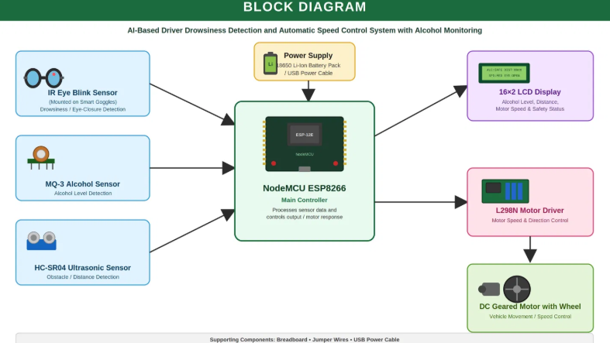
Fig. 3.1 Block Diagram of the AI-Based Driver Drowsiness Detection and Automatic Speed Control System with Alcohol Monitoring
Working of the Block Diagram:
- Power Supply: The 18650 Li-ion battery pack (or USB power cable) powers the NodeMCU ESP8266, sensors, and LCD display, and supplies the L298N motor driver stage.
- IR Eye Blink Sensor (mounted on Safety Goggles): Continuously monitors the driver's eye state to detect drowsiness/eye-closure.
- MQ-3 Alcohol Sensor: Detects the alcohol level in the cabin air and reports an analog reading to the NodeMCU.
- HC-SR04 Ultrasonic Sensor: Measures the distance to obstacles ahead of the vehicle for obstacle/distance detection.
- NodeMCU ESP8266 (Main Controller): Processes the sensor data and controls the motor response and the Wi-Fi web dashboard.
- 16×2 LCD Display: Shows the live alcohol level, distance, and motor speed/safety status for continuous monitoring.
- L298N Motor Driver: Controls the DC geared motor's speed and direction based on commands from the NodeMCU.
- DC Geared Motor with Wheel: Represents vehicle movement/speed control in the prototype.

3.3 Flowchart
The flow of operation begins when the system powers ON and continuously loops through sensor reading, threshold-based hazard evaluation, and actuator control, as summarised below and illustrated in the flowchart.
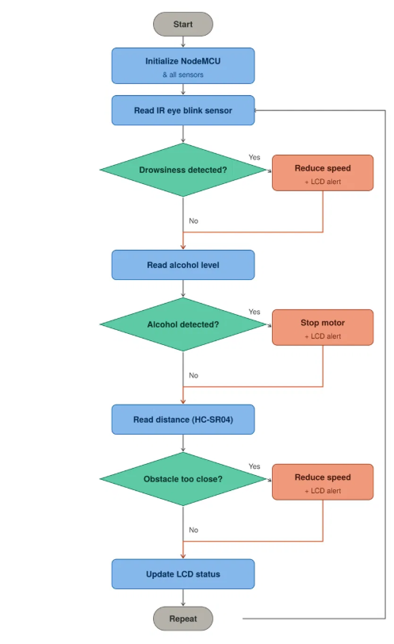
Fig. 3.2 Flowchart of the AI-Based Driver Drowsiness Detection and Automatic Speed Control System with Alcohol Monitoring
- START - Power ON the system and initialise the NodeMCU ESP8266 and all sensors.
- Read the IR eye blink sensor to check the driver's eye state.
- Drowsiness Detected? If YES - reduce the motor speed and show an alert on the LCD.
- If NO - proceed to read the alcohol level from the MQ-3 sensor.
- Alcohol Detected? If YES - stop the motor and show an alert on the LCD.
- If NO - proceed to read the distance from the HC-SR04 ultrasonic sensor.
- Obstacle Too Close? If YES - reduce the motor speed and show an alert on the LCD.
- If NO - update the LCD with the current status.
- Repeat the loop continuously - back to reading the IR eye blink sensor.

3.4 Hardware Requirements
The hardware components used in the project, along with their specifications, quantities, and purpose, are listed below.
S.No. | Component | Specification / Qty | Purpose
1 | NodeMCU ESP8266 | Wi-Fi Microcontroller, 1 No. | Main microcontroller, Wi-Fi connectivity, and decision-making unit
2 | L298N Motor Driver Module | Dual H-Bridge Motor Driver, 1 No. | Controls DC motor speed and direction
3 | DC Geared Motor with Wheel | 6V DC Geared Motor, 1 No. | Represents the vehicle drivetrain / speed control
4 | 18650 Lithium-Ion Battery Pack | 3.7V Li-ion Battery Pack, 1 No. | Portable power source for the prototype
5 | 16×2 LCD Display | I2C 16×2 Display, 1 No. | Displays alcohol level, distance, and speed/system status
6 | HC-SR04 Ultrasonic Sensor | Ultrasonic Distance Sensor, 1 No. | Detects obstacle/distance ahead of the vehicle
7 | MQ-3 Alcohol Sensor | Alcohol Detection Sensor, 1 No. | Detects alcohol concentration in the cabin air
8 | IR Eye Blink Sensor | IR Eye-Closure Sensor, 1 No. | Detects eye closure/drowsiness (used with Safety Goggles)
9 | Breadboard | Standard Prototyping Board, 1 No. | Used for circuit assembly and testing
10 | Jumper Wires | Male-to-Male / Male-to-Female, Assorted | Interconnects all modules
11 | USB Power Cable | Micro-USB Cable, 1 No. | Powers/programs the NodeMCU ESP8266
12 | Safety Goggles | Standard Protective Goggles, 1 No. | Mounting platform for the IR eye blink sensor

Description of Key Components
- NodeMCU ESP8266: Acts as the central controller, running the sensor-fusion decision logic, motor-speed control, and the Wi-Fi web dashboard.
- L298N Motor Driver Module: Drives the DC geared motor's speed and direction based on commands from the NodeMCU.
- DC Geared Motor with Wheel: Represents the vehicle drivetrain and demonstrates the automatic speed-control response in the prototype.
- 18650 Lithium-Ion Battery Pack: Provides a portable power source for the NodeMCU, sensors, LCD, and motor-driver stage.
- 16×2 LCD Display: Displays the live alcohol level, obstacle distance, and motor speed/system status for local monitoring.
- HC-SR04 Ultrasonic Sensor: Measures the distance to obstacles ahead of the vehicle for obstacle-based speed control.
- MQ-3 Alcohol Sensor: Detects ethanol vapour concentration in the cabin air for alcohol-impairment detection.
- IR Eye Blink Sensor: Mounted on the safety goggles to detect eye closure and flag driver drowsiness.
- Breadboard: Used for circuit assembly and testing of the sensor and control connections.
- Jumper Wires: Interconnect the NodeMCU, sensors, LCD, and motor driver on the breadboard.
- USB Power Cable: Provides USB power to the NodeMCU ESP8266 during programming and testing.
- Safety Goggles: Serve as the mounting platform for the IR eye blink sensor in front of the driver's eye.

3.5 Software Requirements
The software tools required for developing and deploying the project are listed below.
S.No. | Software | Description
1 | Arduino IDE | Used to write, compile, and upload the embedded program to the NodeMCU ESP8266.
2 | ESP8266 Board Package | Provides NodeMCU ESP8266 board support and libraries within the Arduino IDE.
3 | Embedded C/C++ | Programming language used to develop sensor reading, decision logic, and control functions.
4 | ESP8266WiFi, ESP8266WebServer & LiquidCrystal_I2C Libraries | Provide Wi-Fi connectivity, the live web dashboard, and control of the 16×2 I2C LCD display.
5 | Serial Monitor | Displays live sensor readings and system status for debugging and testing.

3.6 AI-Based Safety Features
In addition to basic sensor readings, the system incorporates the following smart, rule-based features to improve driver safety:
- Drowsiness Detection: The IR eye blink sensor, mounted on the safety goggles, continuously monitors eye closure; prolonged closure beyond a set time limit progressively reduces the motor speed.
- Alcohol Detection: The MQ-3 sensor reading is compared against two calibrated thresholds - a moderate level that limits the motor to a reduced speed, and a high level that stops the motor completely.
- Obstacle Distance Control: The HC-SR04 ultrasonic sensor measures the distance ahead and graduates the motor speed down as the obstacle gets closer, stopping the motor within the minimum safe distance.
- Sensor Fusion for Speed Control: The control logic takes the lowest (safest) of the eye-closure, alcohol, and distance speed values to decide the final motor speed, and also accepts a manual RUN/STOP command from the Wi-Fi web dashboard, reducing false alarms compared to a single-sensor approach.
Together, these features transform the system from a simple sensor readout into an intelligent driver-safety assistant capable of anticipating hazards and intervening automatically - and remotely, via the web dashboard - to help prevent accidents.

3.7 Development Process
The development of the project was carried out in the following stages:
Step 1: Analyse the project requirements and identify driver-safety and automation objectives.
Step 2: Select the required hardware components - NodeMCU ESP8266, L298N motor driver, DC geared motor, MQ-3 alcohol sensor, IR eye blink sensor, HC-SR04 ultrasonic sensor, and 16×2 LCD display.
Step 3: Design and assemble the circuit on a breadboard, including the power supply, sensor interfacing, and motor-driver stage.
Step 4: Develop the embedded program in Arduino IDE, implementing sensor reading, speed-control decision logic, and the Wi-Fi web dashboard.
Step 5: Integrate the 16×2 LCD display for real-time local status monitoring.
Step 6: Test the system under normal, drowsy, alcohol-present, and obstacle-present conditions.
Step 7: Verify system performance, calibrate thresholds, and optimise the design for reliability and response time.

Chapter 4 - Implementation

4.1 Project Development
The AI-Based Driver Drowsiness Detection and Automatic Speed Control System with Alcohol Monitoring was developed through a structured process to achieve an intelligent, reliable, and low-cost driver-safety solution. Development began with identifying the project objectives and selecting suitable hardware components, including the NodeMCU ESP8266 microcontroller, L298N motor driver, DC geared motor, MQ-3 alcohol sensor, IR eye blink sensor (mounted on safety goggles), HC-SR04 ultrasonic sensor, and 16×2 LCD display.
A circuit was designed and assembled on a breadboard to establish communication between the sensors, the NodeMCU, and the output stages (motor driver and LCD display). The system software was then developed using the Arduino IDE, where the NodeMCU was programmed to read sensor data, apply the speed-control decision logic, and control the motor driver, LCD display, and Wi-Fi web dashboard automatically.
After hardware and software integration, the complete system was assembled onto a compact prototype base housing the NodeMCU, sensors, LCD display, and motor-driver stage. The system was then tested under a range of simulated driving conditions to verify its performance, response time, and reliability, and necessary calibration was performed based on the test results.

4.2 Circuit Diagram
The circuit consists of the following connections and stages:
- Power Supply: The 18650 Li-ion battery pack (or USB power cable) powers the NodeMCU ESP8266, sensors, and 16×2 LCD display; the same supply drives the L298N motor driver and DC geared motor.
- NodeMCU ESP8266 Core: Acts as the central controller, connecting to the configured Wi-Fi network to host the live web dashboard.
- Sensor Connections: The MQ-3 alcohol sensor is connected to the analog input (A0); the IR eye blink sensor (mounted on the safety goggles) is connected to a digital input (D3); the HC-SR04 ultrasonic sensor's trigger and echo pins are connected to D5 and D6 respectively.
- LCD Display: The 16×2 I2C LCD is connected over I2C (SDA - D2, SCL - D1) to display live system status.
- Motor Driver Stage: The L298N motor driver receives control signals from D7 (ENA), D0 (IN1), and D4 (IN2) to control the speed and direction of the DC geared motor.
- Wi-Fi / Web Monitoring: The NodeMCU's built-in Wi-Fi hosts a web page for live status display and RUN/STOP control from any browser on the same network.
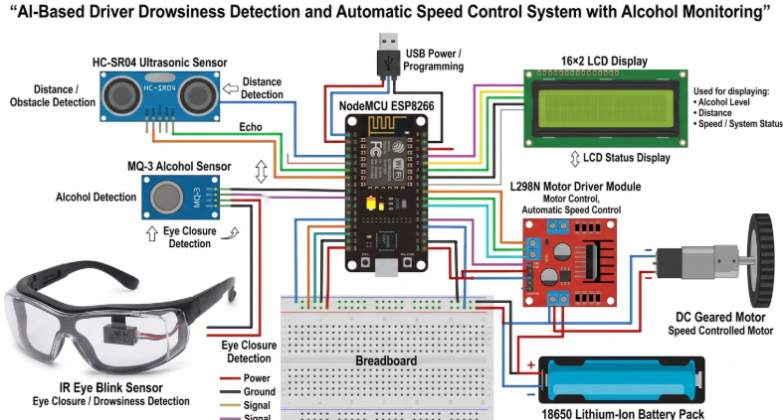
Fig. 4.1 Complete Circuit Diagram
NodeMCU ESP8266 Pin Connections
Device | NodeMCU Pin
16×2 LCD (I2C) SDA / SCL | D2 / D1
L298N ENA / IN1 / IN2 | D7 / D0 / D4
MQ-3 Alcohol Sensor (Analog) | A0
IR Eye Blink Sensor (Digital) | D3
HC-SR04 TRIG / ECHO | D5 / D6
Wi-Fi (Web Dashboard) | Onboard (built into ESP8266)

Circuit Description
The AI-Based Driver Drowsiness Detection circuit is designed around the NodeMCU ESP8266 microcontroller, which serves as the central control unit. A power supply from the 18650 Li-ion battery pack (or USB cable) powers the NodeMCU, MQ-3 sensor, IR eye blink sensor, HC-SR04 sensor, and 16×2 LCD display, and also drives the L298N motor driver and DC geared motor stage. The IR eye blink sensor continuously reports the driver's eye state to the NodeMCU over D3, while the MQ-3 and HC-SR04 sensors report alcohol and distance data over A0 and D5/D6 respectively. Based on the combined sensor-fusion logic, the NodeMCU drives D7/D0/D4 to control the L298N motor driver, which progressively reduces the DC motor's speed and can bring it to a stop whenever an unsafe condition is detected. The 16×2 LCD display continuously shows the live status for local monitoring, while the built-in Wi-Fi hosts a web dashboard for remote monitoring and RUN/STOP control, making the overall circuit efficient, reliable, and suitable for driver-safety applications.

4.3 NodeMCU ESP8266 Program (Source Code)
Below is a simplified Arduino IDE (ESP8266) program suitable for inclusion in the project report. It demonstrates the working of the AI-Based Driver Drowsiness Detection and Automatic Speed Control System with Alcohol Monitoring using the IR eye blink sensor, MQ-3, and HC-SR04 sensors, with 16×2 LCD, Wi-Fi, and L298N motor-driver integration.
// AI-Based Driver Drowsiness Detection and Automatic
// Speed Control System with Alcohol Monitoring
// NodeMCU ESP8266 Arduino Code (Simplified for Report)

#include <ESP8266WiFi.h>
#include <ESP8266WebServer.h>
#include <Wire.h>
#include <LiquidCrystal_I2C.h>

const char* ssid = "LOGESH";
const char* password = "123456789";

ESP8266WebServer server(80);
LiquidCrystal_I2C lcd(0x27, 16, 2);

const int ENA = D7; // L298N speed (PWM)
const int IN1 = D0; // L298N direction
const int IN2 = D4; // L298N direction
const int MQ3_PIN = A0; // MQ-3 alcohol sensor
const int EYE_PIN = D3; // IR eye blink sensor
const int TRIG_PIN = D5; // HC-SR04 trigger
const int ECHO_PIN = D6; // HC-SR04 echo

int alcoholThreshold1 = 500; // alcohol "DETECTED" level
int alcoholThreshold2 = 650; // alcohol "DRUNK" level
const unsigned long eyeCloseLimit = 5000; // ms before speed drops
const float stopDistanceCm = 10.0;

bool manualStop = false; // set from the web RUN / STOP button

void setMotorSpeed(int percent) {
int duty = map(percent, 0, 100, 0, 1023);
analogWrite(ENA, duty);
}

float measureDistanceCm() {
digitalWrite(TRIG_PIN, LOW); delayMicroseconds(2);
digitalWrite(TRIG_PIN, HIGH); delayMicroseconds(10);
digitalWrite(TRIG_PIN, LOW);
long duration = pulseIn(ECHO_PIN, HIGH, 30000);
return (duration == 0) ? -1.0 : duration * 0.0343 / 2.0;
}

int getDistanceSpeed(float d) {
if (d < 0) return 100;
if (d <= stopDistanceCm) return 0;
if (d <= 20) return 10;
if (d <= 30) return 40;
if (d <= 40) return 70;
return 100;
}

void controlSystem(int alcoholRaw, bool eyeClosed,
unsigned long eyeClosedFor, float distanceCm) {
if (manualStop) { setMotorSpeed(0); return; } // web STOP

int alcoholSpeed = 100;
if (alcoholRaw > alcoholThreshold2) alcoholSpeed = 0; // DRUNK
else if (alcoholRaw > alcoholThreshold1) alcoholSpeed = 60;

int distanceSpeed = getDistanceSpeed(distanceCm);

int eyeSpeed = 100;
if (eyeClosed && eyeClosedFor >= eyeCloseLimit) eyeSpeed = 0;

int motorSpeedPercent = min(alcoholSpeed, min(distanceSpeed, eyeSpeed));
setMotorSpeed(motorSpeedPercent);

lcd.clear();
lcd.setCursor(0, 0);
lcd.print(eyeClosed ? "Eye:CLOSED" : "Eye:OPEN");
lcd.setCursor(0, 1);
lcd.print("Spd:"); lcd.print(motorSpeedPercent); lcd.print("%");
}

void handleData() { // JSON status for the web page
String json = "{\"alcohol\":" + String(analogRead(MQ3_PIN)) + "}";
server.send(200, "application/json", json);
}

void handleCommand() { // RUN / STOP from the web page
String act = server.arg("act");
if (act == "stop") manualStop = true;
else if (act == "run") manualStop = false;
server.send(200, "text/plain", "OK");
}

void setup() {
Serial.begin(115200);
pinMode(ENA, OUTPUT); pinMode(IN1, OUTPUT); pinMode(IN2, OUTPUT);
pinMode(EYE_PIN, INPUT);
pinMode(TRIG_PIN, OUTPUT); pinMode(ECHO_PIN, INPUT);

lcd.init();
lcd.backlight();

WiFi.begin(ssid, password);
while (WiFi.status() != WL_CONNECTED) delay(500);

server.on("/data", handleData);
server.on("/cmd", handleCommand);
server.begin();
}

void loop() {
server.handleClient();

int alcoholRaw = analogRead(MQ3_PIN);
bool eyeClosed = digitalRead(EYE_PIN);
float distanceCm = measureDistanceCm();

controlSystem(alcoholRaw, eyeClosed, eyeCloseLimit, distanceCm);
delay(200);
}

4.4 Working Principle
The AI-Based Driver Drowsiness Detection and Automatic Speed Control System with Alcohol Monitoring operates by continuously monitoring the driver's eye state, the cabin alcohol level, and the distance to obstacles ahead, and automatically responding to unsafe conditions. The IR eye blink sensor, mounted on the driver's safety goggles, continuously reports the eye-closure state to the NodeMCU ESP8266 controller.
The control logic evaluates all three inputs together. If the eyes remain closed beyond the set time limit, the motor speed is progressively reduced and an alert is shown on the LCD. The alcohol level from the MQ-3 sensor is compared against two thresholds - a moderate level limits the motor to a reduced speed, while a high level stops the motor completely. The distance measured by the HC-SR04 ultrasonic sensor is used to graduate the motor speed down as an obstacle gets closer, stopping the motor within the minimum safe distance. The system always applies the lowest (safest) of the three calculated speeds, and a manual STOP command from the web dashboard overrides all other inputs to stop the motor immediately.
Throughout operation, the current alcohol level, obstacle distance, eye state, and motor speed/system status are displayed on the 16×2 LCD for local monitoring, and the same status is published to the Wi-Fi web dashboard, where the driver or an observer can also issue RUN/STOP commands remotely. This combination of eye-closure detection, gas sensing, ultrasonic distance sensing, and Wi-Fi connectivity allows the system to react faster and more reliably than manual driver self-monitoring alone.

4.5 Implementation Steps
Step 1: Collect the required hardware and software components.
Step 2: Assemble the circuit using the NodeMCU ESP8266, MQ-3, IR eye blink sensor, HC-SR04, 16×2 LCD, and L298N motor driver with DC geared motor.
Step 3: Develop and upload the control program to the NodeMCU ESP8266 using the Arduino IDE.
Step 4: Test the system for eye-closure detection, alcohol detection, and obstacle-distance detection independently.
Step 5: Integrate all sensors together and verify the combined decision logic and automatic speed-control response.
Step 6: Mount all components onto the prototype base plate, connect to Wi-Fi, and verify the complete hardware assembly and web dashboard.

4.6 Hardware Prototype
The completed hardware prototype integrates the NodeMCU ESP8266 controller, MQ-3 alcohol sensor, IR eye blink sensor (mounted on safety goggles), HC-SR04 ultrasonic sensor, 16×2 LCD display, and L298N motor driver with DC geared motor onto a compact base plate, as illustrated in the block and circuit diagrams above and the photograph of the assembled prototype below. The layout keeps the sensing and driver electronics compactly housed while the eye-blink sensor remains positioned in front of the driver's eye and the ultrasonic sensor faces forward for obstacle detection.
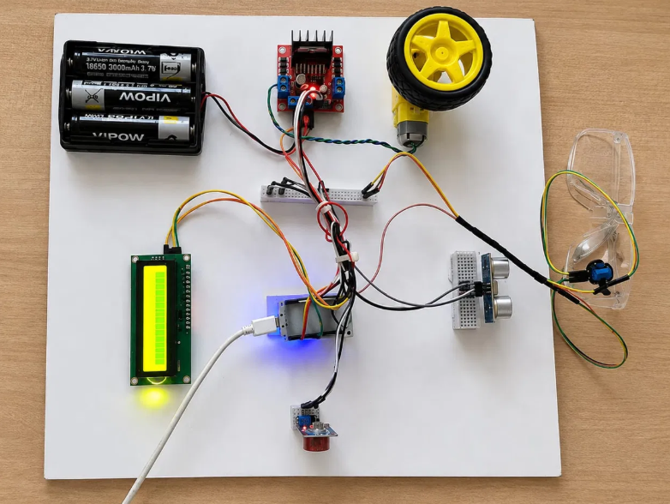
Fig. 4.2 Prototype of AI-Based Driver Drowsiness Detection and Automatic Speed Control System with Alcohol Monitoring

Chapter 5 - Results and Discussion

5.1 Output
The AI-Based Driver Drowsiness Detection and Automatic Speed Control System with Alcohol Monitoring successfully monitors the driver's eye state, the cabin alcohol level, and the obstacle distance in real time. During testing, the system correctly displayed the live status (e.g., alcohol level, distance, and motor speed) on the 16×2 LCD. The motor speed was automatically reduced, and the motor stopped, whenever prolonged eye closure, a high alcohol level, or a very close obstacle was detected, and normal speed was restored automatically once conditions returned to safe levels.
The Wi-Fi web dashboard correctly reflected the live alcohol, distance, eye, and motor-speed status, and the manual RUN/STOP button reliably started and stopped the motor on command, confirming reliable local and remote monitoring.

5.2 Testing
The project was tested under several operating conditions to evaluate its performance, as summarised in the table below.
Test Case | Expected Result | Actual Result | Status
Power ON | System initialises and LCD displays status | System initialised, LCD displayed live status | Pass
Normal Driving | Motor runs at normal speed | Motor ran at 100% speed, LCD showed normal status | Pass
Simulated Eye Closure | Motor speed reduced progressively | Motor speed stepped down and LCD showed drowsiness alert | Pass
Alcohol Simulation (Moderate) | Motor speed limited | Motor speed reduced, LCD showed alcohol alert | Pass
Alcohol Simulation (High) | Motor stopped | Motor stopped, LCD showed alcohol alert | Pass
Obstacle Detected (HC-SR04) | Motor speed reduced with distance | Motor speed reduced progressively as obstacle approached | Pass
Manual STOP / RUN (Web) | Motor stops/resumes on command | Motor responded correctly to the web RUN/STOP button | Pass
Recovery to Safe State | Motor resumes normal speed | Motor speed restored automatically | Pass

The testing confirmed that the system operated reliably and according to the design requirements across all evaluated scenarios.

5.3 Observations
- The system accurately detected simulated drowsiness through the IR eye blink sensor's eye-closure readings.
- The motor speed was automatically reduced, and the motor stopped, whenever an unsafe condition was detected.
- The MQ-3 sensor reliably captured alcohol readings and correctly flagged both the moderate and high alcohol thresholds.
- The HC-SR04 sensor provided a fast, accurate response to simulated obstacles, progressively reducing the motor speed as the distance decreased.
- The sensor-fusion logic successfully combined all three inputs to decide on the correct, safest motor speed at all times.
- The 16×2 LCD display and the Wi-Fi web dashboard both updated the live status with minimal latency throughout testing.
- The overall system demonstrated stable and responsive operation throughout the testing period, including reliable manual RUN/STOP control from the web dashboard.

5.4 Advantages
- Provides continuous, automated monitoring of driver drowsiness, cabin alcohol level, and obstacle distance.
- Reduces fatigue- and alcohol-related accident risk through fast, multi-sensor hazard detection and automatic speed control.
- Automatically reduces vehicle speed and stops the motor without requiring manual driver intervention.
- Provides real-time local status feedback through the 16×2 LCD display and remote status/control through the Wi-Fi web dashboard.
- Reduces dependence on the driver's own self-awareness, improving safety during long drives and night travel.
- Offers a low-cost, compact, and scalable design suitable for two-wheelers, cars, and public transport vehicles.

Chapter 6 - Conclusion and Future Scope

6.1 Conclusion
The AI-Based Driver Drowsiness Detection and Automatic Speed Control System with Alcohol Monitoring successfully demonstrates an intelligent, safe, and responsive driver-safety solution using the NodeMCU ESP8266 microcontroller, together with an IR eye blink sensor, an MQ-3 alcohol sensor, and an HC-SR04 ultrasonic sensor, combined with sensor-fusion decision logic and L298N motor-driver-controlled speed regulation. The system automatically reduces vehicle speed and stops the motor based on drowsiness, alcohol, and obstacle-distance detection, while continuously updating the driver through a 16×2 LCD display and a Wi-Fi web dashboard.
The project offers a cost-effective, reliable, and scalable solution for reducing fatigue- and alcohol-related road accidents, and highlights the practical application of low-cost embedded sensing, sensor fusion, and IoT-based remote monitoring in improving everyday road safety.

6.2 Future Scope
- Addition of a GSM module to send SMS or call alerts to a registered emergency contact when a critical event is detected.
- Integration of a mobile application for push-notification alerts and trip-history logging alongside the existing web dashboard.
- Use of a camera-based drowsiness-detection module to complement the IR eye blink sensor for higher-accuracy detection.
- Cloud-based data logging and analytics to identify driving patterns and provide personalised safety insights.
- Integration with the vehicle's actual ECU and braking system for real-world deployment beyond the prototype stage.
- Addition of a seatbelt and steering-grip sensor to further improve the accuracy of driver-state detection.

6.3 References
1. Espressif Systems. ESP8266 / NodeMCU Development Board Documentation. https://www.espressif.com/
2. Arduino. Arduino IDE Documentation. https://www.arduino.cc/
3. MQ-3 Alcohol Gas Sensor Datasheet, Winsen Electronics.
4. HC-SR04 Ultrasonic Distance Sensor Datasheet.
5. STMicroelectronics / Various. L298N Dual H-Bridge Motor Driver Datasheet.
6. HD44780 16×2 LCD with PCF8574 I2C Adapter Datasheet.
7. ESP8266WiFi and ESP8266WebServer Library Documentation, Arduino-ESP8266 Core.
8. IEEE Research Papers on IoT-Based Driver Drowsiness Detection and Alcohol Sensing Systems.

